|  |
| --- |
| Synechron logo - Whitebase |
| Automation Feasibility Study |
|  |
|  |
| **Synechron** |
|  |

|  |
| --- |
|  |

**Table of Contents**

1. Executive Summary 4

1.1 Objective 4

2. Application Understanding & Gap Analysis 5

2.1 <<Application Name>> 5

2.2 <<Application Name>> 7

3. Technology & Test Process Summary 10

3.1 Technology Table for all applications 10

3.2 Test process Analysis 10

4. Tools Evaluation 12

5. Recommendation 13

5.1 Tool Recommendation 13

5.2 Regression Suite Automation 13

Version

|  |  |  |  |
| --- | --- | --- | --- |
| Date | Version | Author | Description |
| November 23, 2012 | 0.1 | QA CoE | Initial Version |
| November 24, 2012 | 1.0 | QA CoE | Final Version after review |

Reviewed By

|  |  |
| --- | --- |
| Date | Name |
| November 24, 2012 | Venu M.S |

# Executive Summary

<<Brief about Customer and their business>> <<Client Name>>has sought Services of Synechron to help in gap analysis & automation tool evaluation. >>

Synechron has partnered with various clients for similar initiatives and understands the issues related to automation, best practices and has requisite infrastructure to support automation including various automation tools and frameworks (Hybrid, keyword, business and data driven).

## Objective

* <<Test Automation –Identify current test automation processes, technology and depth of automation framework. >>
* <<Test Tool Evaluation - Document automation tool comparison on best suitability for <<client name>> applications (technical & functional requirements) using various evaluation parameters.
* Future State Recommendation for test tool & regression automation.

# Application Understanding & Gap Analysis

<<Several applications are also being changed and / or upgraded / and this requires test automation to ensure full functionality and any changes and/or modifications have not impacted the applications ability to perform.

Application understanding covers functional & technical understanding. Current processes are also highlighted below to avoid duplication of efforts during automation process.

Ratings of 0 to 5 are used to highlight suitability for automation, 0 being minimum & 5 maximum. >>

## <<Application Name>>

**Functionally:**

<<Provide functionality of <<application name>> at high level. >>

**Technically:**

<<Provide information about technologies, web service, databases and any other technology used for the application development and updated below table. >>

<<

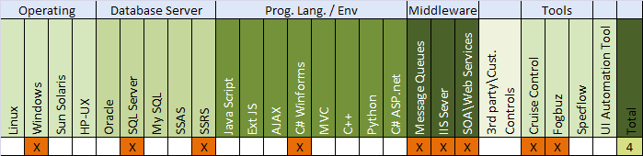

**>>**

**Process:**

<<Provide information about current QA automation or manual testing process used by client for the application. Example:

* No Requirement Traceability matrix outlining coverage produced by manual test cases.
* Agile process is used for development.
* No structured manual Test cases. Test cases are written on story structure making it difficult to identify the updated or latest cases.
* No regression test coverage during each builds due to timelines; may lead to Defect Leakage. No Defect-Test Cases- Requirement traceability.

>>

**Gap Analysis:**

<<Provide information about gap analysis related to documents, quality of test cases/requirement and test processes if any and update below table>>

<<

|  |  |  |  |
| --- | --- | --- | --- |
| S. No | Documents | Rating | Remarks |
| 1 | Manual Test Cases | 3 | 1. Incomplete set of test cases 2. Test Cases are documented Story or sprint wise. Difficult to create regression suites out of it. |
| 2 | Regression Test Suite | 2 | 1. Regression test suites are not covered for all modules. 2. Few Regression suites are available for particular sprint however not for the entire project or modules. |
| 3 | Requirement Traceability Matrix | 0 | 1. No RTM for test Coverage. |
| 4 | Automation Priority | 5 | 1. Automation Priority high per client. 2. No measurement of Defect leakage; mostly due to strict timelines. |
| 5 | Manual Execution Efforts | 4 | 1. Manual execution efforts are on higher side. |
| 6 | Frequency of Changes | 3 | 1. Continuous application changes – monthly builds. 2. Complete regression testing may uncover few defects leading to more changes. |
| 7 | Application Stability | 4 | 1. Less UI or screen changes 2. No major change in application navigation. |
| 8 | Ease of | 3 | 1. Average manual test case complexity 2. Less complex functionality or calculation, in turn helps in ease of automation. |
|  |  |  |  |
|  | Automation |  | 1. Interaction with other applications is not complex & can be automated. |
| 9 | Technology Evaluation | 4 | 1. The Automation tools support most Tools and technology used for this application. 2. Message Queues and Web Services (JSON) are complex however feasible to automate. 3. Technology comparison Matrix is highlighted above. |

Note: Rating should vary between 0 - 5 >>

## <<Application Name>>

**Functionally:**

<<Provide functionality of <<application name>> at high level. >>

**Technically:**

<<Provide information about technologies, web service, databases and any other technology used for the application development and updated below table. >>

<<



**>>**

**Process:**

<<Provide information about current QA automation or manual testing process used by client for the application. Example:

* No Requirement Traceability matrix outlining coverage produced by manual test cases.
* Agile process is used for development.
* No structured manual Test cases. Test cases are written on story structure making it difficult to identify the updated or latest cases.
* No regression test coverage during each builds due to timelines; may lead to Defect Leakage. No Defect-Test Cases- Requirement traceability.

>>

**Gap Analysis:**

<<Provide information about gap analysis related to documents, quality of test cases/requirement and test processes if any and update below table>>

<<

|  |  |  |  |
| --- | --- | --- | --- |
| S. No | Documents | Rating | Remarks |
| 1 | Manual Test Cases | 3 | 1. Incomplete set of test cases 2. Test Cases are documented Story or sprint wise. Difficult to create regression suites out of it. |
| 2 | Regression Test Suite | 2 | 1. Regression test suites are not covered for all modules. 2. Few Regression suites are available for particular sprint however not for the entire project or modules. |
| 3 | Requirement Traceability Matrix | 0 | 1. No RTM for test Coverage. |
| 4 | Automation Priority | 5 | 1. Automation Priority high per client. 2. No measurement of Defect leakage; mostly due to strict timelines. |
| 5 | Manual Execution Efforts | 4 | 1. Manual execution efforts are on higher side. 2. Lot of manual text and values comparison that can be done faster and better using automation tools. |
| 6 | Frequency of Changes | 3 | 1. Continuous application changes – monthly builds. 2. Complete regression testing may uncover few defects leading to more changes. |
| 7 | Application Stability | 4 | 1. Less UI or screen changes 2. No major change in application navigation. |
| 8 | Ease of Automation | 3 | 1. Average manual test case complexity 2. Less complex functionality or calculation, in turn helps in ease of automation. 3. Interaction with other applications is not complex & can be automated. |
| 9 | Technology Evaluation | 4 | 1. The Automation tools support most Tools and technology used for this application. 2. Message Queues and Web Services (JSON) are complex however feasible to automate. 3. Technology comparison Matrix is highlighted above. |

Note: Rating should vary between 0 - 5>>

# Technology & Test Process Summary

## Technology Table for all applications

<<Provide information about all the application against technologies used for respective application. Please refer to Technally point of each application. Example:

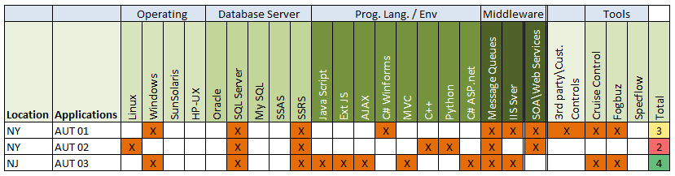>>

## Test process Analysis

<<Prepare table with below parameters. Example:

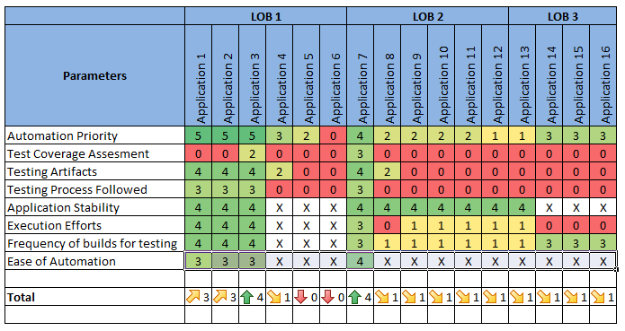

<<Summaries the findings based on preliminary analysis we have made the following conclusions:

1. Very little or no Test Documentation (Test Cases, Test Plan, Test Strategy, Metrics Test Reports).
2. Lack of QA Ownership
3. No Test to Requirement traceability.
4. No Defined processes – Ad-hoc Test Coverage / Execution>>

# Tools Evaluation

<<Tool1, Tool2, Tool3, Tool4 and Tool4 are used for tool evaluation based on technology used and current market position of these automation tools.

Emphasize was given on commercial aspect, customer support, integration with Continuous integration tools & technology supported.

Weight-ages were provided to rate tool against different evaluation parameters.>>

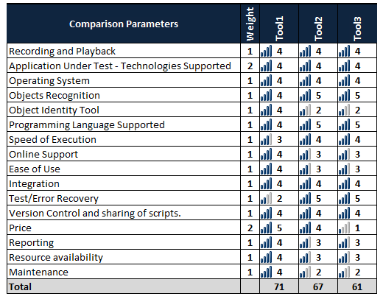

<<Detailed description of each parameter can be found in below document.>>

<<Attach details automation tool observation and findings document.>>

# Recommendation

## Tool Recommendation

<<Based on the evaluation ratings; Tool1 & Tool2 can be considered for automation.

Tool1 & Tool2 are the leading tools in market along with <<best fit tool name>> however <<best fit tool name>> is our recommendation based on the fact that it **satisfies all the functional requirements** and is the most **cost efficient product in terms of license cost**.

Also Synechron has resource availability for <<best fit tool name>> and training capabilities if required. >>

## Regression Suite Automation

<<Based on Gap Analysis & Technology analysis for each application described above, following four applications are recommended for initial automation.

i) **Application 1** ii) **Application 2**

**Other applications can follow later based on process improvements**.

Few of the important recommendation for all applications before automation begins –

* Creating Testing Artifacts (Test Cases, Test Reports, Test Plans)
* Coverage Matrix (RTM & Defect to Test Cases)
* Thorough testing of applications before proceeding to automation to ensure minimal changes & stable application.
* In nutshell, it will be important to achieve strategic goals (test documentation) before proceeding for strategic goal (Regression Automation)>>